1. Show all of the information on the Avengers.

Query:select * from avengers

b. Columns: 21

c. Expected row count: 171 count

d. Screenshot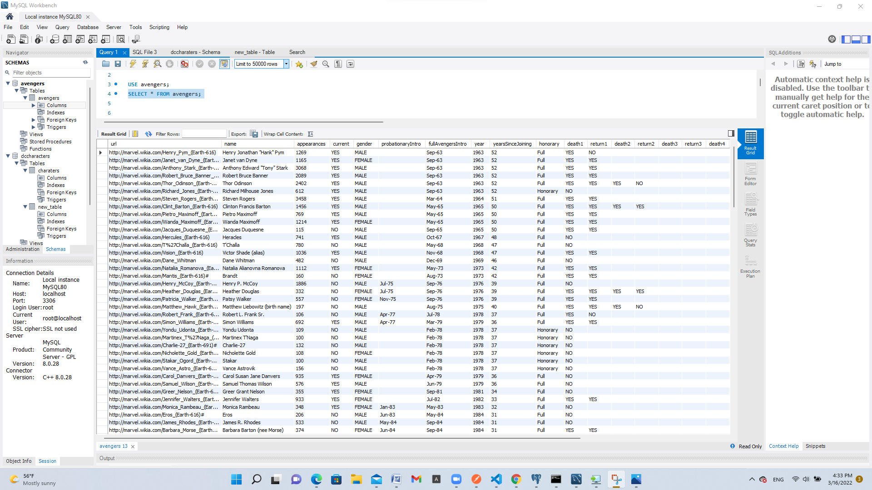

1. Create a new table with information from another super hero group [can be imported from elsewhere or fictitious]. Make sure there is an appropriate header and must be at least 30 rows.

a. Query: -- CREATE TABLE Charaters(

-- Charaters_ID varchar(2),

-- Charaters_NAME varchar(40),

-- Charaters_WEAPONS varchar(20),

-- Charaters_SUPERPOWERS varchar(20)

-- );

INSERT INTO Charaters VALUES('25','Superman','1001','2000');

INSERT INTO Charaters VALUES('26','Batman','1000','1000');

INSERT INTO Charaters VALUES('27','WonderWoman','500','500');

INSERT INTO Charaters VALUES('27','WonderWoman','500','500');b. Columns: 4

c. Expected row count: 30

d. Screenshot 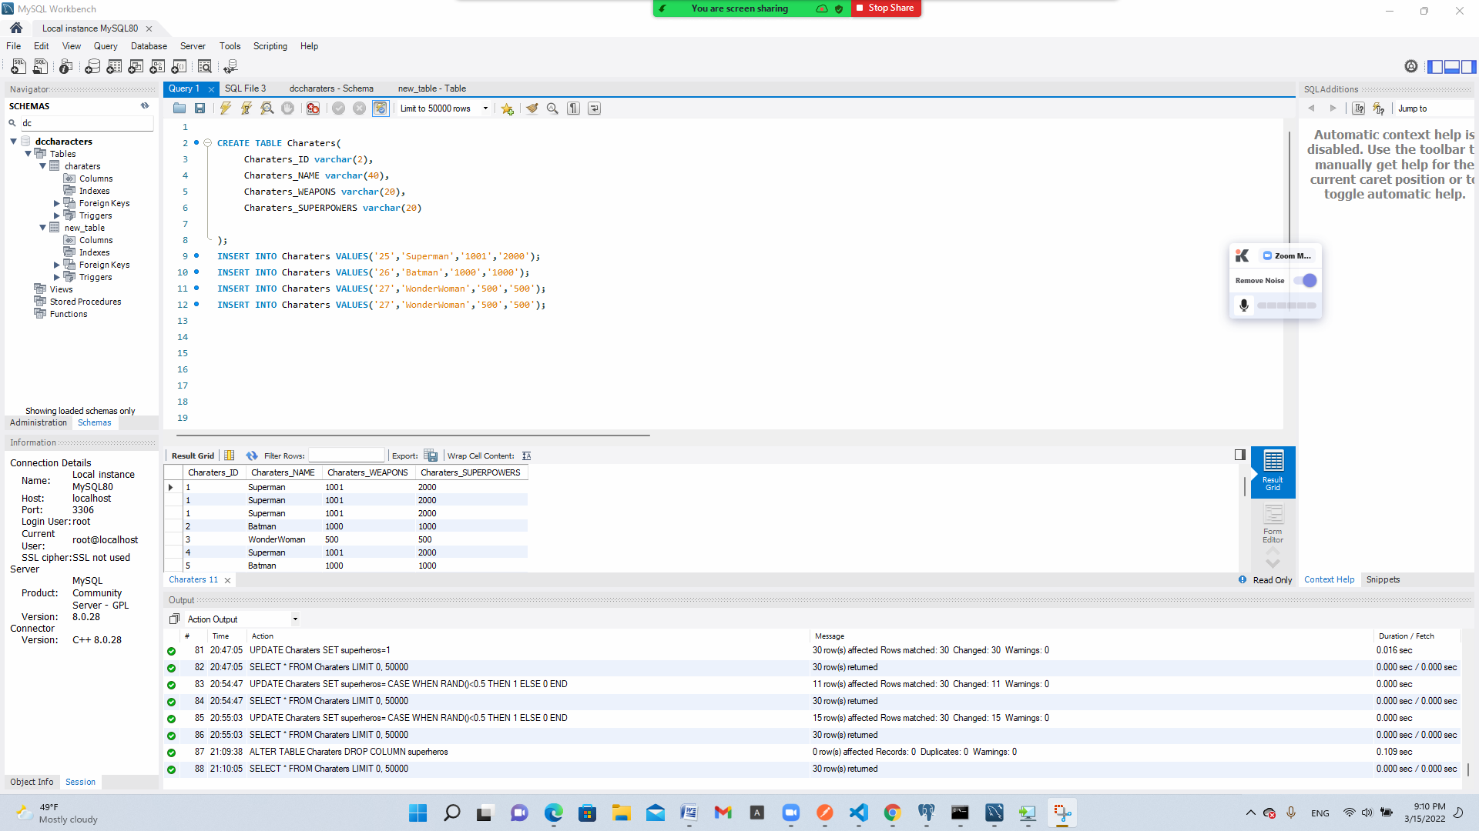

1. Add a column to your new table (let us call it the new superheros) for those who are interested in joining the Avengers. Make this be randomly assigned.

a. Query: -- INSERT INTO Charaters VALUES('25','Superman','1001','2000');

-- INSERT INTO Charaters VALUES('26','Batman','1000','1000');

-- INSERT INTO Charaters VALUES('27','WonderWoman','500','500');

-- INSERT INTO Charaters VALUES('27','WonderWoman','500','500');

b. Columns: 4

c. Expected row count: 30

d. Screenshot 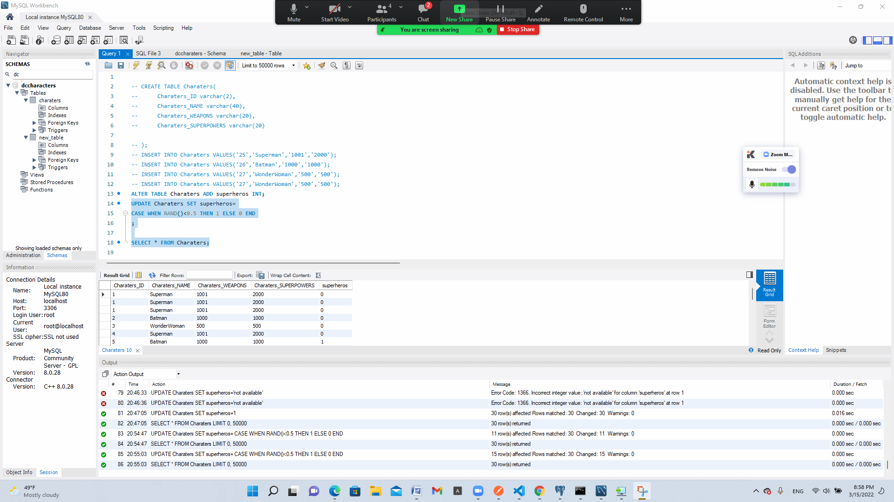

***Hint:****it is okay for this to be a multi-step query.  You will have to use rand() function and CASE WHEN statement too.*

1. Add a column to your new table (the new superheros) for their favorite Avenger (have it randomly choose between  Anthony Edward "Tony" Stark,  Robert Bruce Banner, & Victor Shade).

a. Query: ALTER TABLE charaters ADD superheros INT;

UPDATE charaters SET superheros=

CASE WHEN RAND()<0.5 THEN 1 ELSE 0 END

;

SELECT * FROM charaters;b. Columns: 22

c. Expected row count: 30

d. Screenshot 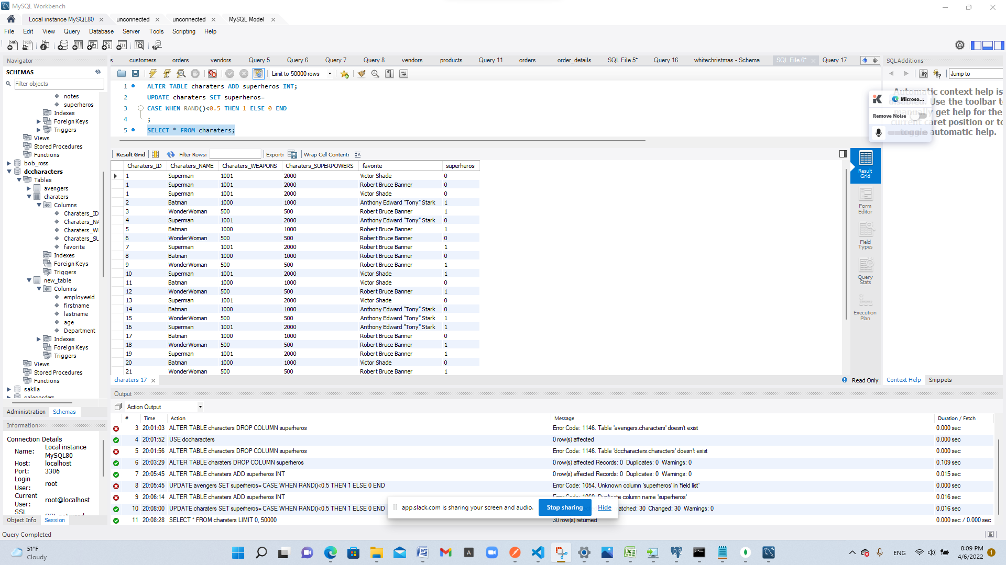

1. Use a JOIN statement between the two tables for who is interested in joining the Avengers.

a. Query:

b. Columns:

c. Expected row count:

d. Screenshot

1. List all Avengers who have more than 1000 appearances in alphabetic order.

a. Query:SELECT * FROM avengers WHERE appearances < 1000;

b. Columns: 22

c. Expected row count: 20

d. Screenshot 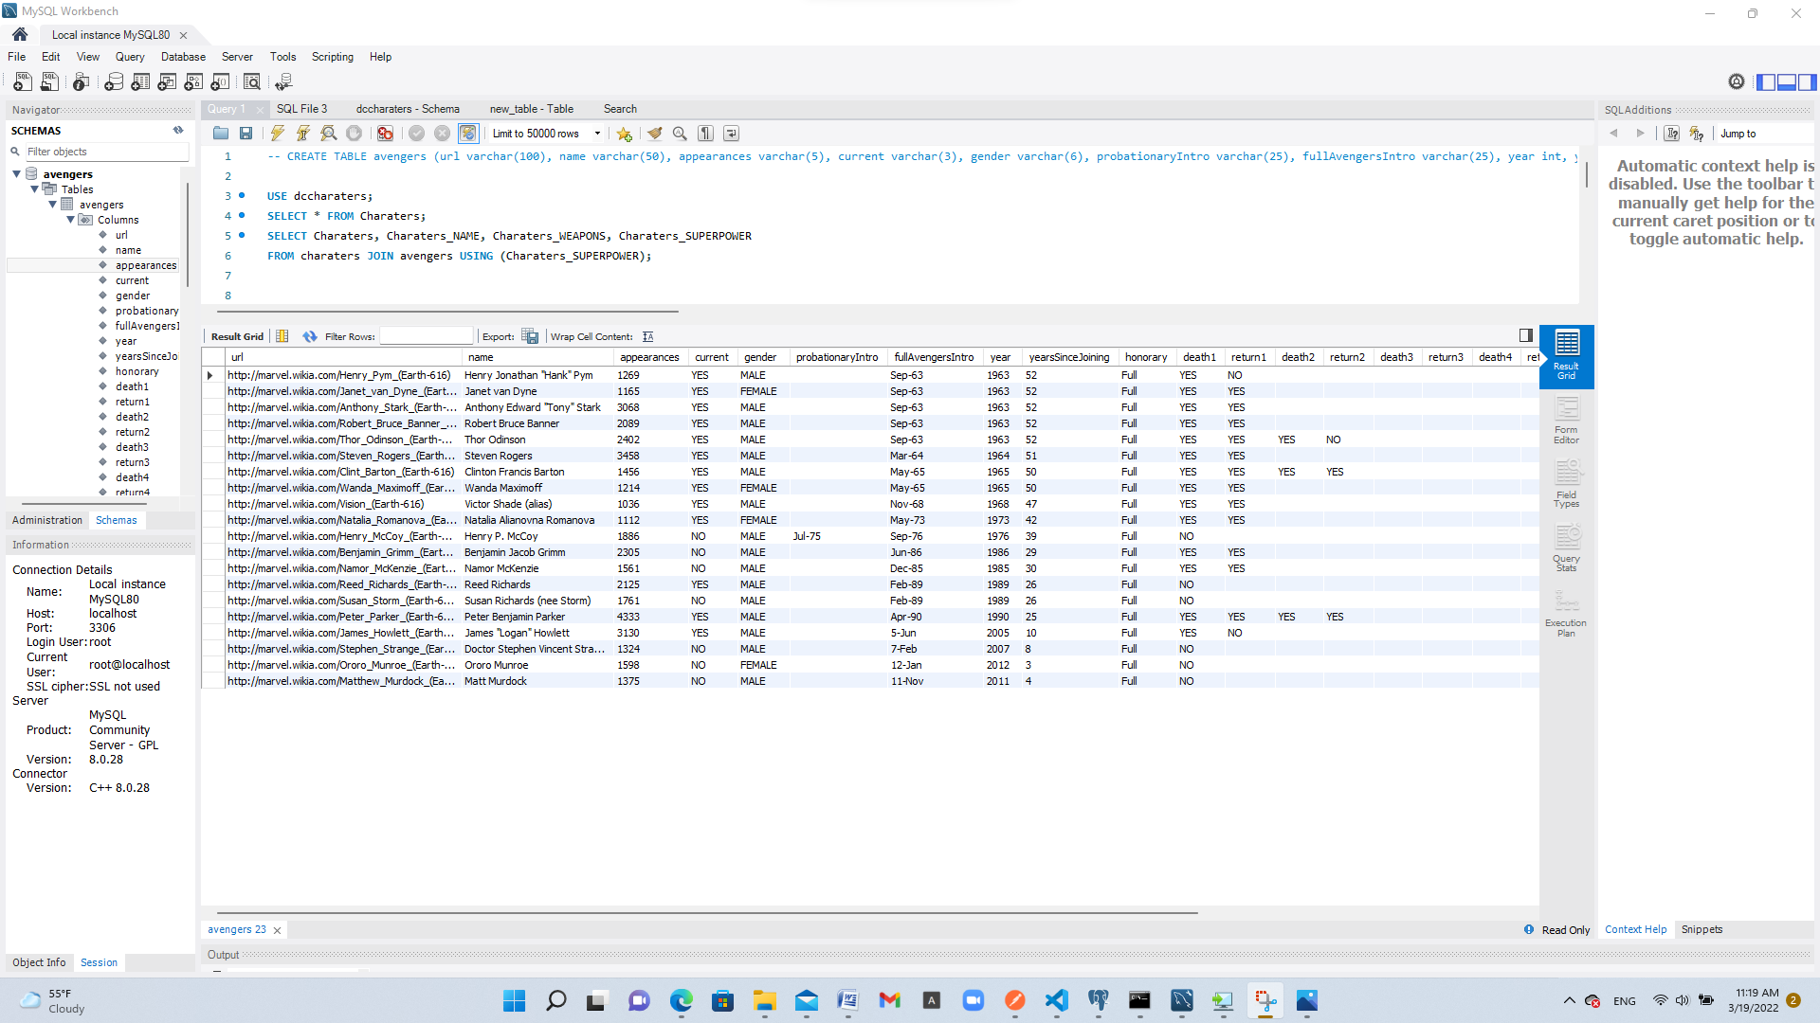

1. What Avengers do not have more than 1000 appearances?

a. Query: Query:SELECT * FROM avengers WHERE appearances < 1000;

b. Columns: 22

c. Expected row count: 151

d. Screenshot 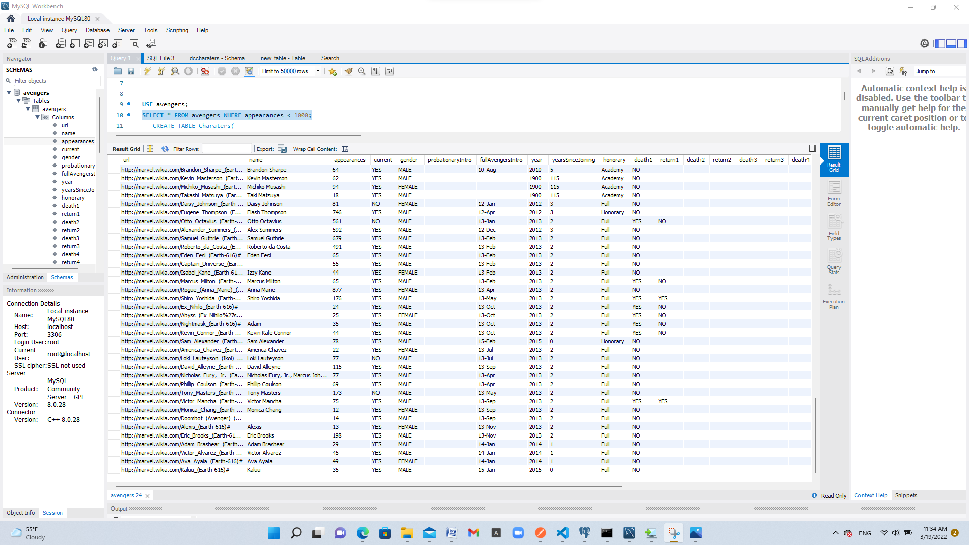

1. Not more than 500?

a. Query: SELECT * FROM avengers WHERE appearances < 500;

b. Columns: 22

c. Expected row count: 128

d. Screenshot 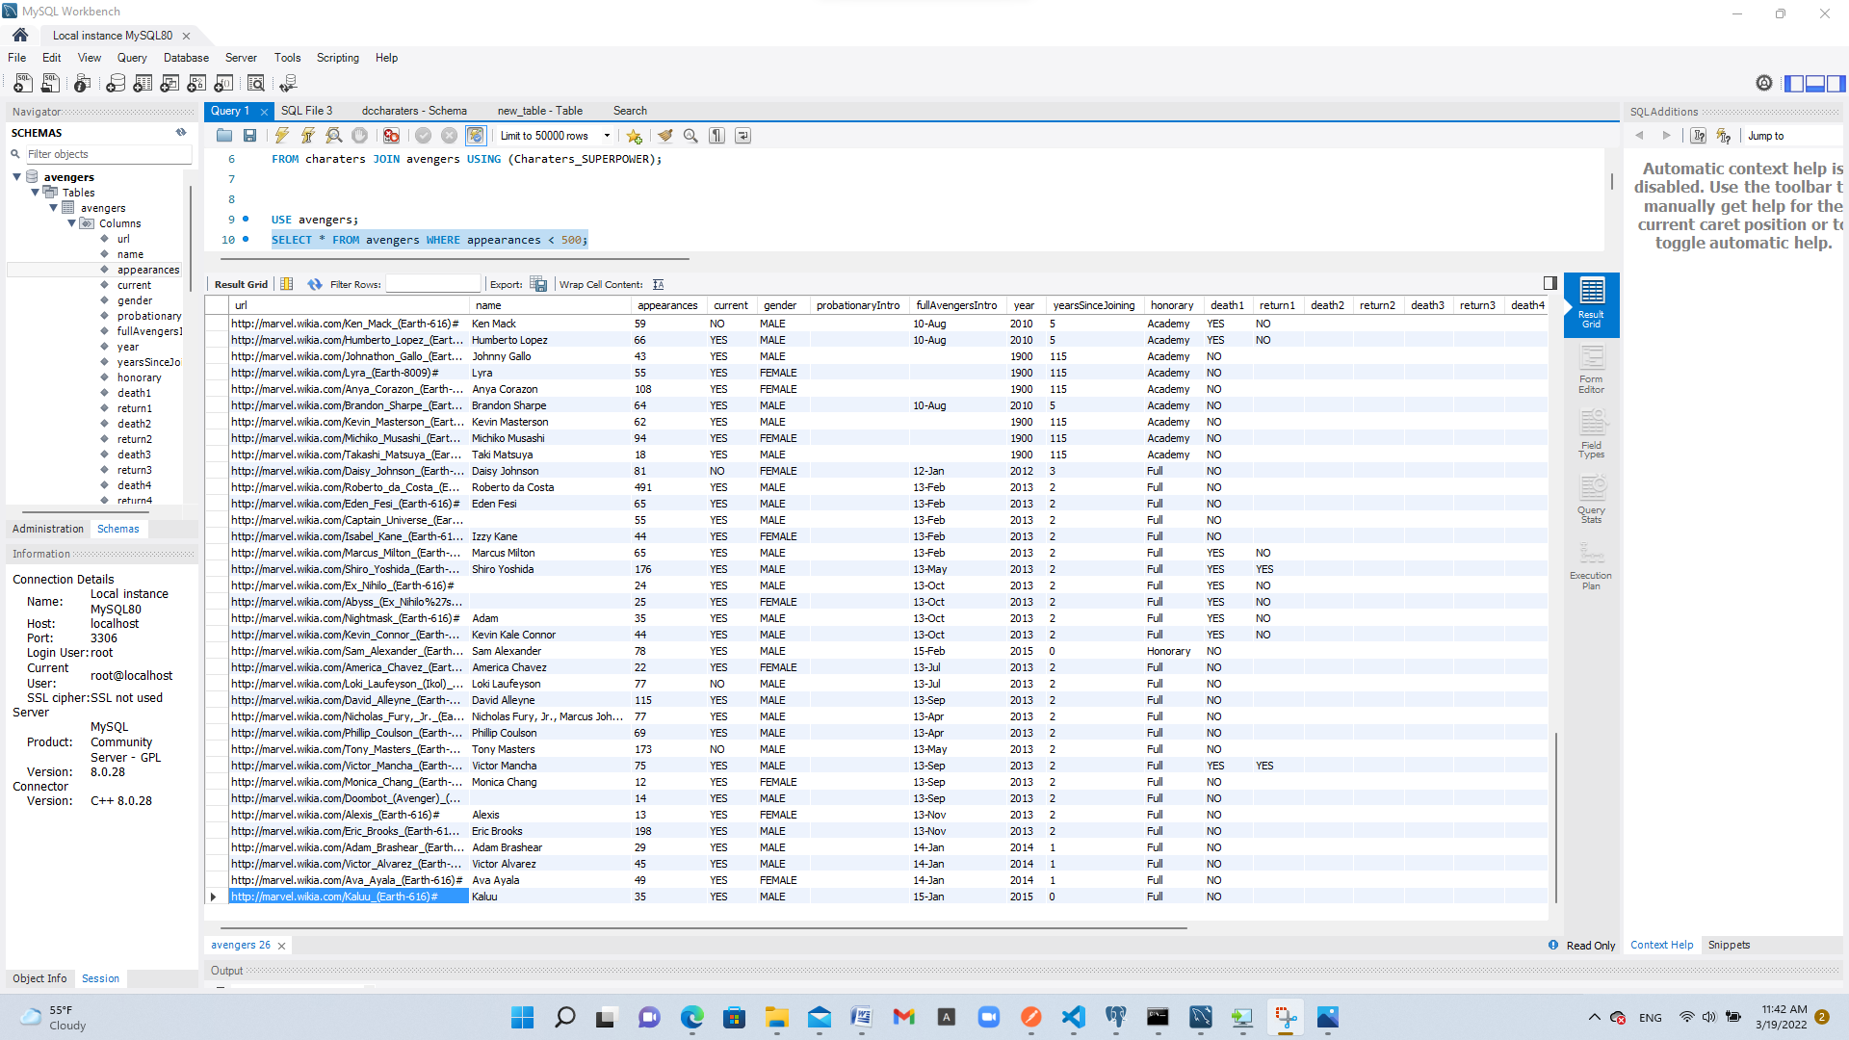

1. Not more than 50 and female?

a. Query: SELECT * FROM avengers WHERE appearances < 50;

b. Columns: 22

c. Expected row count: 18

d. Screenshot 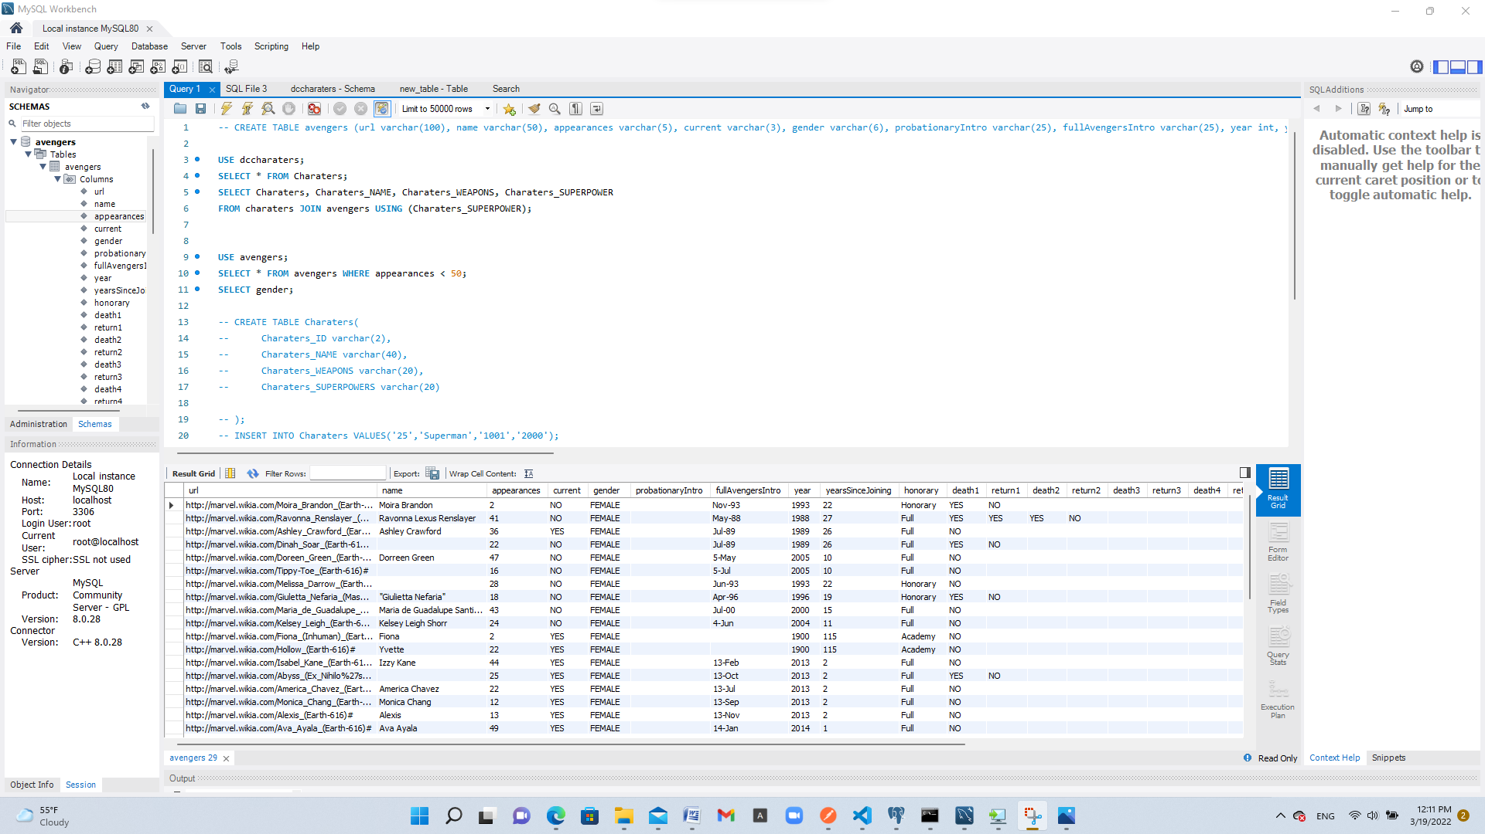

1. More than 150, male, and are full member?

a. Query: SELECT * FROM avengers WHERE appearances < 150;

b. Columns: 22

c. Expected row count: 57

d. Screenshot 